**The RIPPLES study**

**Child aged 8-12 years - Information Sheet**

Hi, my name is Simon Hammond. I work at the University of East Anglia. I am leading a team trying to find out more about how we can help keep children your age safer online.

We know that people make mistakes when learning how to use the internet. We also know that different children learn differently.

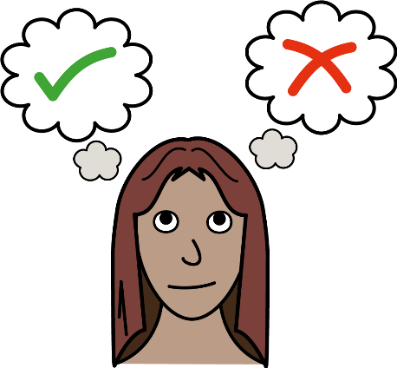But no one knows how to measure how children can recover from making mistakes online so we are trying to make one. We would like your help with this. **You don’t have to, it’s up to you.**

We have asked your parent/carer if this would be okay. This sheet will help you to talk to them about the study and decide if you want to take part.

If you do want to take part and then you change your mind, that’s okay. Please just tell your parent/carer. If you have any questions, you can ask your parent/carer to ask us.

**What will happen if I say that I want to be in the project?**

If you decide to take part, we will ask you to:

* Fill in an online questionnaire
* Answer some general questions like your age, sex and where you are from
* Answer some questions about your digital resilience

**There are no right or wrong answers.**

**What will happen if I change my mind?**

If you do want to take part and then you change your mind, that’s okay. Just close the online questionnaire. Because we won’t know who filled in our questionnaire we won’t be able to delete your answers once you have submitted them.

**Will anyone else know what I say in the study?**

No, we won’t have any way to tell anyone else how you answer our questions.

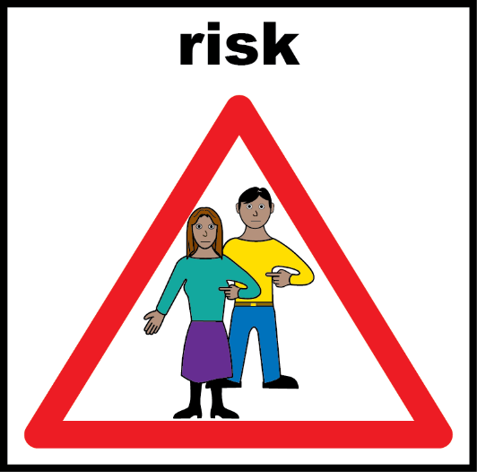

All the information that we have about you from the study will be stored in a safe place and we will look after it very carefully. We will write a report about the study and show it to other people, but we won’t put your name in the report, and no one will know that you’re in the study.

**How long will the study take?**

The study should take around 10-15 minutes in total.



**Are there any good things about being in the project?**

By talking to us and other people your age about our questionnaire you will be helping us do our project. We would also like to thank you for your time so will arrange for £2 to be sent to your parent or carer.

**Are there any bad things about being in the project?**

This project will take up some of your time, but we don’t think it will cost you anything. We do not think answering our questions will upset you. If this does happen you can stop at any time and please talk to your parent/carer about how you feel. You may also find the following website useful:

* Advice about online safety - <https://www.childline.org.uk/info-advice/bullying-abuse-safety/online-mobile-safety/staying-safe-online/>

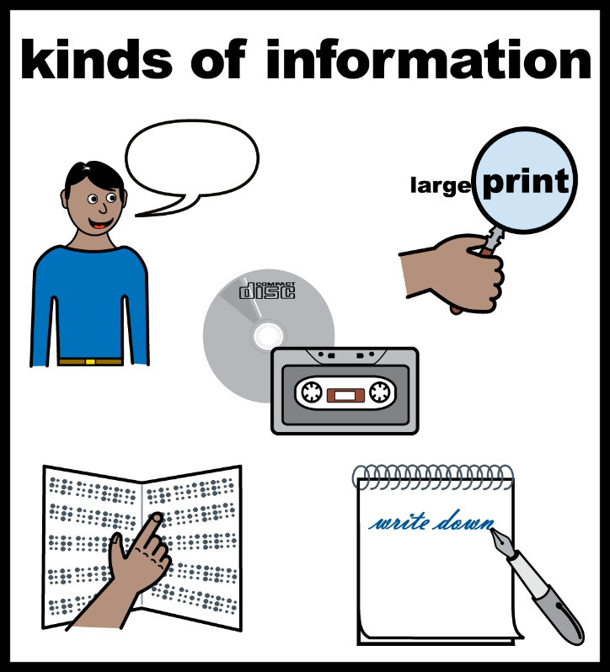**Will you tell me what you learnt when the study ends?**

Yes, if you want. We have included details of how to do this and told your parent/ carer how to do this.

**What if I am not happy with the study or the people doing the study?**

If you are not happy with how we are doing the study then ask your parent/carer to:

* Email Simon Hammond (who is in charge of this study) on [s.hammond@uea.ac.uk](mailto:s.hammond@uea.ac.uk)
* Or email Simon’s boss Professor Yann Lebeau [Y.Lebeau@uea.ac.uk](mailto:Y.Lebeau@uea.ac.uk)

**Okay, I want to take part, what do I do next?**

Talk to your parent/carer and follow the link/QR code to our online survey.